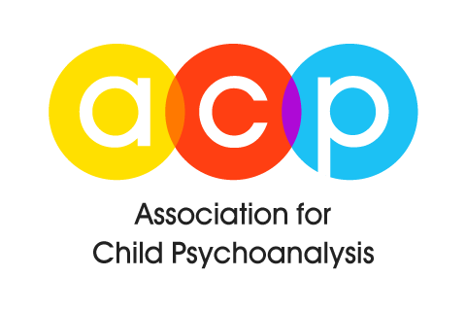
2023 Annual Meeting
Then and Now: The Evolving Lenses of Child and Adolescent Psychoanalysis

May 5-7, 2023
San Diego, CA

This is an in-person event for ACP members.
The 2023 annual conference will highlight the evolution of theory and clinical practice on a number of topics central to analytic work with children and adolescents. The four clinical workshops and the plenary session will integrate theoretical perspectives with detailed clinical process material. These presentations collectively demonstrate work with children at different development levels, emphasizing transference and countertransference. In addition, the weekend will include panels on contemporary consideration of gender identity in preschool children, as well as traditional and contemporary views of latency or middle childhood. In addition, the program includes a workshop focused on writing about analytic process with children and adolescents.
Friday, May 5th
9:00 – 10:30 a.m. WRITING WORKSHOP
This workshop will focus on writing about patient dynamics and the analytic process in work with child and adolescent patients. A case example will demonstrate the challenges inherent in the writing process, as well as ways of effectively responding to these challenges.
10:30 – 11:30 a.m. PRESIDENT’S HOUR
Open discussion time for ACP members.

11:45 a.m. – 1:15 p.m. PANEL
“A Discussion of Early Gender Identity Development: Clinical Material From Two Preschool Children”

This panel will focus on early gender identity development in young children. Clinical examples from two treatments will be used to highlight salient questions and ideas.

2:15 – 3:45 p.m. PANEL
“Reframing How We Understand, Diagnose and Treat Children in Middle Childhood.”
This panel will focus on a contemporary reframing of the longstanding conceptual framework of latency. Particular emphasis will be on current theoretical and clinical thinking about this development stage, as well as indications for diagnosis and clinical work with children in middle childhood.
4:00 – 6:00 p.m. CLINICAL WORKSHOPS
Registrants can choose to attend one of four clinical workshops. Each workshop will feature detailed process material from a child or adolescent psychoanalysis, along with a discussion by a senior child analyst who will highlight various aspects of the analytic process. The four workshops will focus on the following topics: a psychoanalytic examination of the development of gender identity in autism; parental loss and mourning in a young child as detailed in an analysis beginning at the age of 3 years; concepts of aggression and the development of identity as they impinge and coalesce in the analysis of an adolescent son of immigrants; and analytic work with an adolescent whose resistances present a number of challenges.
6:45 p.m. DINNER and AWARDS
Saturday, May 6th
8:00 – 9:00 a.m. ACP ANNUAL BUSINESS MEETING
9:00 a.m. – 12:15 p.m. PLENARY PANEL
“The boy who couldn’t stop fighting: Historical and contemporary views of aggression in child and adolescent psychoanalysis”
This panel will explore contemporary and historical psychoanalytic views of aggression, and their implications for clinical technique in the context of child and adolescent psychoanalysis. An analytic treatment extending from childhood into adolescence will highlight the ideas under consideration.
12:30 – 2:00 p.m. PLENARY BREAKOUT GROUPS
The plenary breakout groups allow for small-group discussion of the plenary panel. The breakout groups are led by two senior child analysts and are designed to provide an opportunity for informal exchange of ideas and perspectives.
6:00 – 7:00 p.m. SPECIAL EVENT FOR CHILD ANALYTIC CANDIDATES - Informal Discussion/Q & A
Candidates are invited to an informal session where you can ask questions on any topic for which you'd like input, feedback, or guidance from experienced clinicians and your fellow candidates. Light appetizers will be served.
Sunday, May 7th
9:00 - 10:15 a.m. MARIANNE KRIS MEMORIAL LECTURE
10:45 a.m. - 12:15 p.m. EXTENSION DIVISION PROGRAM

