LESSONS FROM MISTER ROGERS NEIGHBORHOOD

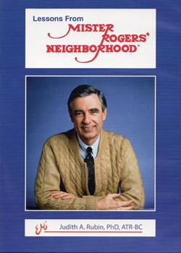
The current popularity of a Fred Rogers documentary is cause for hope for a renewed public appreciation of an analytic perspective about child rearing. Many people, including analysts, are unaware that Fred was, in many ways, an undocumented child analyst. Intimately mentored by Margaret McFarland, a faculty member of the Pittsburgh Psychoanalytic Center, and later, Nancy Curry, a child analyst, Fred came to understand and deeply value an analytic life. Through creativity and talent, Fred translated his deep understandings into puppetry and music, forging a caring, trusting relationship with his young audience and their families.
Several years ago, Judy Rubin, an art therapist and child analyst made a 50 min. film about Fred: “Lessons from Mister Rogers’ Neighborhood.” The “art lady” on Fred’s early shows for several years, Judy became impressed with the power of teaching via film and made a 50 min. film, focusing on Fred’s unique talent to convey complicated psychoanalytic ideas through music and fantasy, in clear and simple language. Stimulated by his own analysis as well as work with Margaret and interactions with Eric Erikson, Helen Ross, Anna Freud and other analysts, Fred focused on conveying “psychoanalytic lessons” through his programs : i.e., recognizing and managing feelings, sublimation, sibling rivalry, splitting, anxieties about one’s anger and bodily integrity, guilt, fear of loss of love, and even oedipal wishes and fears. It’s all there and more, psychoanalysis deconstructed, a valuable teaching tool for all and a reminder that analytic ideas are timeless.
The film can be purchased from Expressive Media, Inc., the producer, for $20, plus $5 shipping from: Info@expressivemedia.org

